CS 230 Module One Assignment

Southern New Hampshire University

CS-230: Operating Platforms

Richard Hren

Professor Fredricks

May 7, 2026

UML Class Diagram for Bicycle Application
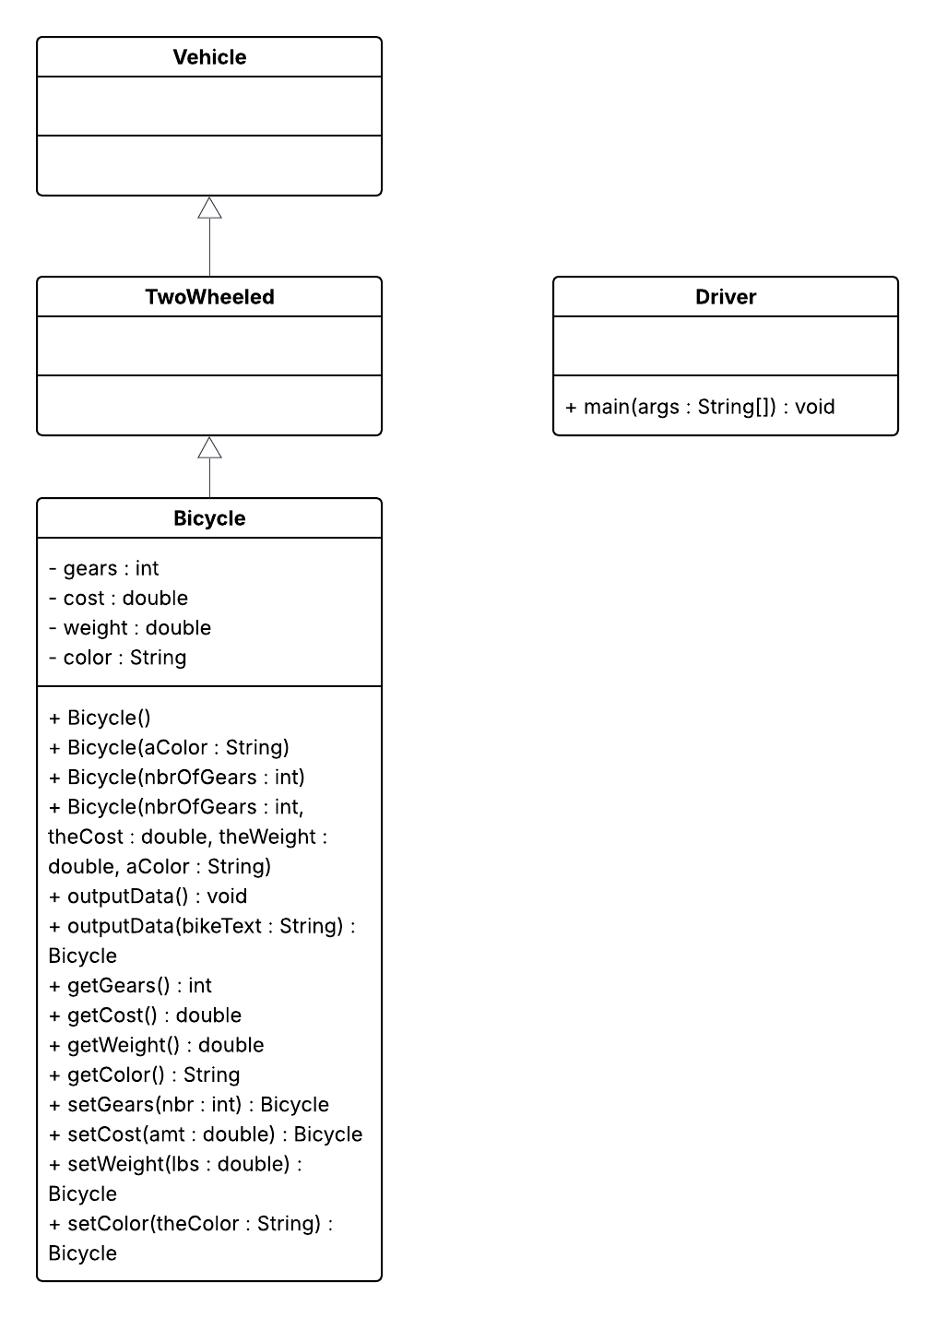

This UML class diagram demonstrates the object-oriented structure of the Java application provided in the assignment. The application contains four classes: Vehicle, TwoWheeled, Bicycle, and Driver. The diagram illustrates inheritance relationships, constructors, methods, attributes, and access modifiers used throughout the program.

From my perspective as an Automation Engineer working with industrial control systems and Rockwell PLC platforms, the class hierarchy used in this project is similar to how equipment and devices are organized in automation systems. Parent classes provide generalized functionality while child classes inherit and expand upon those features for more specialized applications. This helps create structured, reusable, and scalable systems.

The application demonstrates inheritance through the relationships between the classes. The Bicycle class inherits from the TwoWheeled class, and the TwoWheeled class inherits from the Vehicle class. This establishes an “is-a” relationship and allows the child classes to reuse functionality from their parent classes. Similar concepts are used in automation environments where equipment objects may inherit common properties and behaviors from higher-level device structures.

The diagram also demonstrates encapsulation through the use of private instance variables within the Bicycle class. The attributes of gears, cost, weight, and color are declared as private and accessed using public getter and setter methods. This helps protect the integrity of the data and maintain controlled access to the class variables, which is important in both software development and industrial automation systems.

Polymorphism is demonstrated through the use of overloaded constructors and overloaded methods within the Bicycle class. Multiple constructors allow different ways to create Bicycle objects with different parameter sets. The outputData() method is also overloaded to support different method calls and flexibility within the program. Overall, the UML class diagram provides a visual representation of object-oriented programming principles including inheritance, encapsulation, and polymorphism. The project also demonstrates how structured software design concepts can relate to real-world automation and control system architectures.

